SREE NARAYANA GURUKULAM COLLEGE OF ENGINEERING
Fourth semester
Branch: Computer Science and Engineering

CST204 COMPUTER SYSTEM ARCHITECTURE
Tutorial 3
Date-17/06/2021
- APRIL 2018
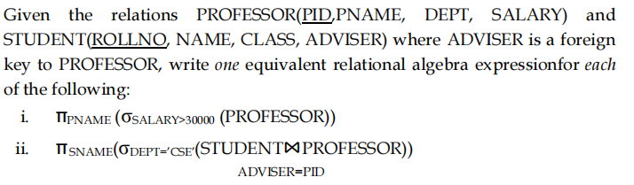
- Dec 2019
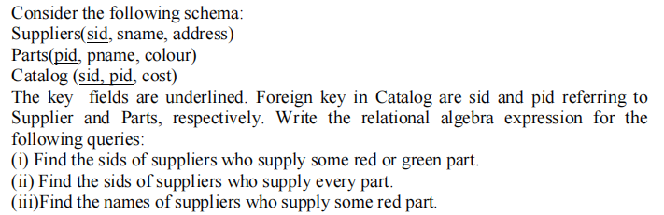

- April 2018
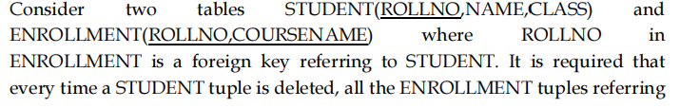
- DEC 2019
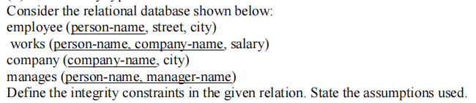

- May2019